Case 5-Asia-China-Hongshan-Dragon-Pendant-Jade-4700 to 2900 BCE

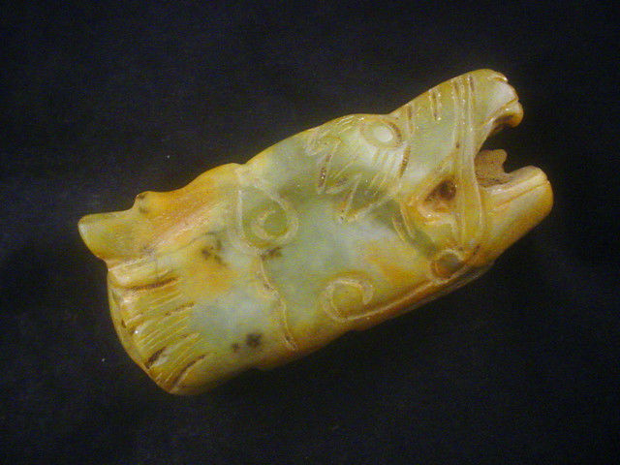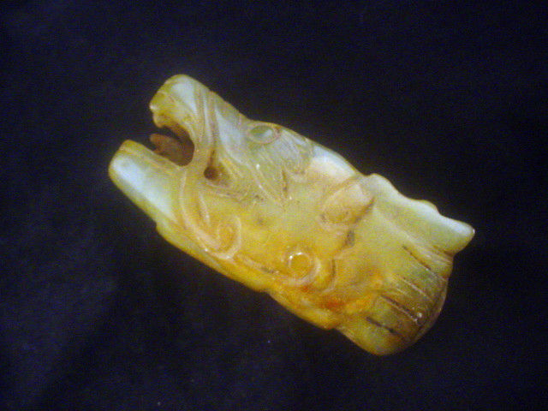

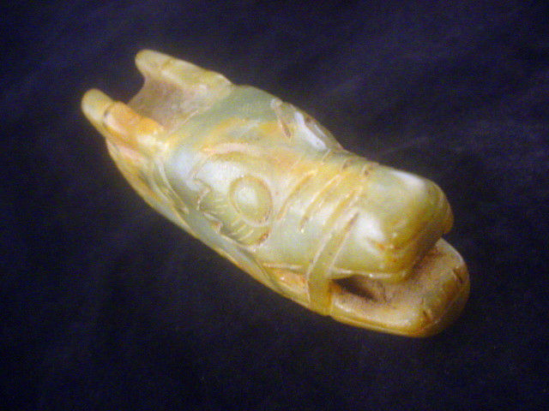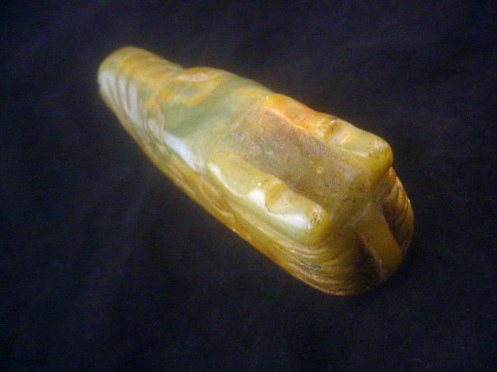

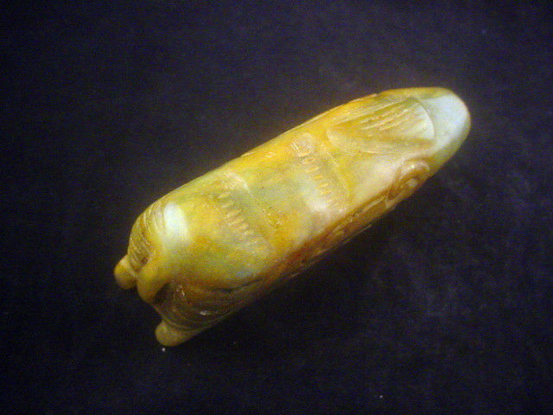

Asia-China-Hongshan-Dragon-Pendant-Jade-4700 to 2900 BCE

Case No.: 5

Accession Number:

Formal Label: Asia-China-Hongshan-Dragon-Pendant-Jade-4700 to 2900 BCE

**Display Description:**

This unusual Hongshan culture ([紅山文化](https://en.wiktionary.org/wiki/紅山文化)) jade head of a dragon may have been from the Liao river basin. It is of a different style from the so-called “pig dragon” designs of Hongshanhou, a site in Hongshan District, Chifeng, which was discovered by the Japanese archaeologist Torii Ryūzō in 1908 and excavated in 1935 by Kōsaku Hamada and Mizuno Seiichi (Hamada 1938).

LC Classification:

Date or Time Horizon:

Geographical Area: NE of Beijing

Map:

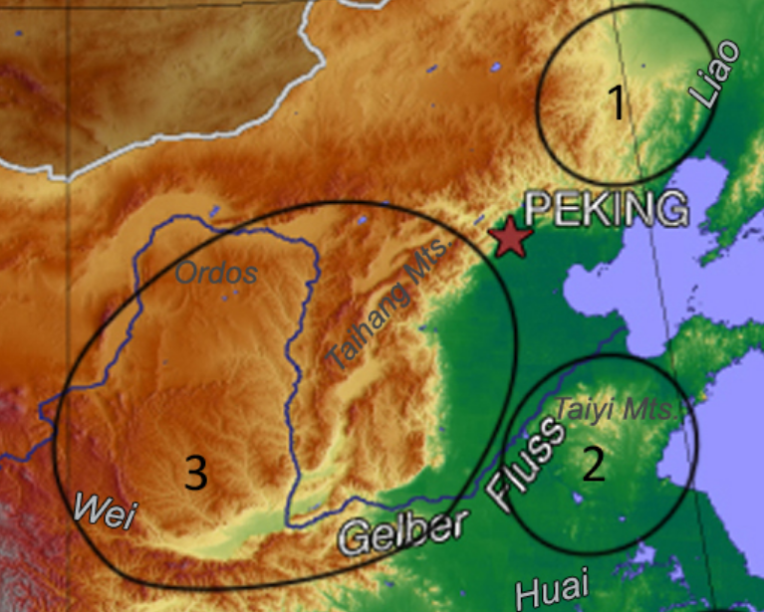

Map of 1. Hongshan, 2. Dawenkou and 3. Yangshao.

After https://upload.wikimedia.org/wikipedia/commons/8/86/China%2C_middle_Neolithic_cultures.jpg

GPS Coordinates:

Cultural Affiliation:

Medium:

**Dimensions**:   
**Weight:**

**Provenance**:

**Condition:**

**Discussion:**

**References:**

Hamada, Kosaku and Mizuno Seiichi. "Chifeng Hongshanhou," *Archaeologia Orientalis,* ser. A, No. 6. Far-Eastern Archaeology Society of Japan, (1938).

Appendix:

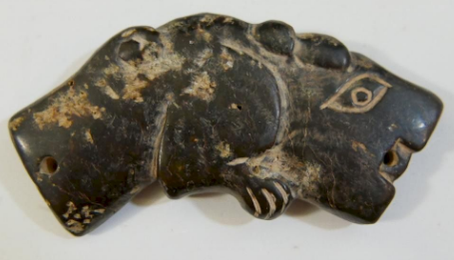

ANTIQUE CHINESE JADE TIGER PENDANT - SHANG DYNASTY by Capitoline Auction Gallery | which is similar in head design to the present example.

SHAPE \* MERGEFORMAT 